

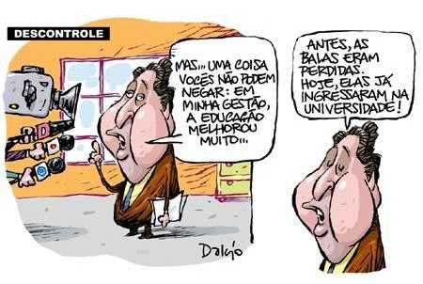

BRAZIL: Currently Situation in Matter occupational health and hygiene (OHS)
“Legislative Focus”

Constitution – Epistle Of Nation
(05/10/98)

BRAZIL FEDERATION REPUBLIC

Chapter II

Social Rights

Article 7º: Laborer (Workers) Rights

XXII – Reduction on risk inherent labor (work) though of rule health, hygiene and security.
XXIII – Supplement of remuneration to hard activity unhealthy (unwholesome) or dangerous in form of law.
XXXVIII – Insurance against work accidents on the responsibility of employer, without exclude damage who is the obligation him when incur fraud our culpability (guiltiness).

Article 202 – It is assurance to retirement after 35 years of labor to men and 30 years to Women or in lower time, to be subject to the work on special condition that harm the health or the physical integrity, this is explicit at law.

- 180.000.000 OF INHABITANT
- 24.000.000 FORMAL WORKERS
- 350.000 BUMPY (RUGGED) ANNUAL
- 3.100 FATAL ACCIDENTS BY YEAR
- 21.000 LABOUR DISEASE
- 36.000 RUGGED INTHE COURSE LABOUR – HOME OR VICE VER-SA
- COSTS (EXPENSES) ARE EQUIVALENT TO 4% OF PIB U$ 30.000.000

- FONTE: MPAS/MTE

SOME RESULTS REMARKED

ORIENTATION OF NATIONAL POLITCS DE SSTT TO REALM PRODUCTIVES MORE DEVELOPED OR MORE DISAGREEMENT
(Enterprise with higher risk)

TENDENCY OF SST IN BRAZIL DUE THE GLOBAL FORMAL ECONOMY

Convergence of Legislation – Mercosul
Socials Clauses ( provision )
Behavior (Conduct) Code and Programs of Social Responsibility

PROPOSITION FOR AN ADAPTATION ACE CHANGE PRESERVING THE CONQUERED VALUABLES

LEGISLATIVE FOCUS
BASIC GUIDELINE

Rules of legal technical are named in Brazil – NR – Normas Regulamentadoras (Regulator Norm – RN), they depends on of principal law (greather law) – CLT – Consolidação das Leis do Trabalho (Labor Laws Consolidation) promulgated in May 1º, 1943 and with its final revision in 1977 by law number 6514.

“CLT”
201 – Articles
Chapter V – Safety and Medicine of Work – SST
Section I – Generals Disposition
Section II- Prior Inspection, Seizure (hindrance) and interdict
Section III- SST services
Section IV- Equipment Individual Protection
Section V - Medicine Of work
Section VI – Edification
Section VII – Illumination
Section VIII – Comfort Thermic
Section IX - Electric Installation
Section X – Movement Of Materials
Section XI Equipments and Machines
Section XII- Boiler and Pattern (Mold )
Section XIII – Unhealthy and danger activities
Section XIV – Fatigue Prevention
Section XV – Protection Especially Measure

IMPACT OF REGULATOR NORM - NR
NR Port. MTb 3214 de 06/05/1978
Advance or retrocession Advance
REGULATION THE LAW
Results of Argument, Discussion Tripartite and Equality

NR – 1 - LEGALS DISPOSITIONS

1 -Establish the application camp: All the place of Labor standing the CLT – Trade, Industry, Transport and others.
2- Cue clears that the enterprise not only must fulfill ace NR, but the legal aptitude of the states and municipal, too. But emphasizing the CLT Rules always will be overlap.
3- Foresee the establishment of rules of engineer security and medicine of work by way of collective conditions of labor, since observed hierarchy of laws.
4 – Concept that employer, employee, enterprise, establishment, sector building site, work station, and work premises.
5- Concern the owe enterprise
6 – Create the obligations of Worker
7 – Characterizes the discipline in Work

NR – 2 - PRIOR INSPECTION

1 – Concern that all new establishment before initiate its activities, must solicit ate approval about its installation to Labor Ministry ( MTE/DRT ):
2 - MTE/DRT after accomplish the prior inspection send out “Installation Approbation Certification – CAI”

NR – 3 - CLOSE OR INTERDICTION

1 – Appraise Serious risks and imminent to the worker – RGIT
2- Establish that Regional Delegate of work can seal off the establishment, sector, machine, or to close the accomplishment.

NR- 4 – SPECIALIZED SERVICES IN SAFETY ENGINEERING AND WORK MEDICINE

1 – Obligatory in private enterprise or public and organs of direct administration or indirect, with employee conducted by CLT:
2 - DIMENSIONS - Depends on the gradation risk of principal activity and total number of employee this establishment
3 – Composition: Safety engineer of work, safety technician of work, nurse of work, and auxiliary nurse of work, registered on Ministry of Work and professional privy.

NR 5 – INTERNAL COMISSION TO PREVENT ACCIDENTS- CIPA

1 – Composition equality that have necessary representation to discuss and conduct solutions about questions of safety and health in work;
2- Presidency member of (patron) protector delegation by designation of own employer and the vice-presidency, to one employee choused between representative (titular) of employees.

NR – 6 - INDIVIDUAL PROTECTION EQUIPMENT – EPI

1 – Precise individual protection equipment
2- Establish the obligation of employer
3- Clarify how the responsibility of employee
4- Characterize the certification of assent – CA
5 – List the principal protection individual equipment

NR – 7 – PROGRAM OF MEDICAL CONTROL AND OCCUPATIONAL HEALTH – PCMSO

- Establish the conditions of obligatory of exams medical admission, periodic and dismissal;
- Expenditure with medical exams be up to employer;
- Establish the development of PCMSO;
- Characterize the coordinator Doctor of PCMSO
- To orient Occupational Health Certificate – ASO

NR – 8 – CONSTRUCTION (BUILDING)

- Establish of safety measurement in erection where are practiced laborious activities
- Dispose on minimum conditions that have minister, floor, walls or steps (stairs) and ramps.

NR – 9 – PROGRAM OF PREVENT AMBIENTAL RISK - PPRA

- Concern and classify the ambient risks in physicals, chemicals and biological
- Establish obligation of employer
- Acquaint about the structure and development of PPRA
- Assure the participation of employee and due the information

NR – 10 – PREMISES AND ELETRICITY SERVICES

- Establish the minimum conditions demanding to guarantee the safety of who work in electric premises in its diverse stage, including project, enforcement (execution) operation maintenance, reform and enlargement and still the assurance of user and third party.
- Cover all the electric premises, any of the stage of production, transmission, distribution and energy consumption;
- Specify that a qualified professional might install, operate, inspect or to reform electric premises.
- Establish the criterion for authorization of electrician;

NR – 11 – TRANSPORT, MOVEMENT, STORAGE AND MOVEMENT OF MATERIALS

1 – Establish the demand and precaution of safety on the movement, handling and storage of materials, including about respect to the recipient and hoard place

- Those, which work in movement of materials, must receive specific training (drill) given by enterprise (Company) and behave (carry) one identification card with name and photography, in visible local.

NR – 12 - MACHINES AND EQUIPMENTS

- Establish relation of premises and area of work with machines and equipments
- Prescribe about rule protection machines and equipments.
- Establish guideline related to fabrication, Import, sale and location (hiring) machines and equipments.
- Establish the basics items related to maintenance and machine operations and equipments.
- Present an enclosure (annex) comparative the Mountains and other of cylinders (rollers of mass).

NR – 13 - BOILER AND VASE UNDER FIRE

- Establish the fully-fledged professional to all the activities related to the boiler and vases under fire: project, premises, operation, maintenance, inspection and superintendence and regulated by system CONFEA-CREA (Engineering and Architecture Federal Council).
- Establish the security gadget that must be gifted the boiler and vases under fire.
- Oblige one periodic accomplishment of safety inspections
- Afford (provide) the administrative Control by means of dossier (record), and of safety register
- Specify the eligibility (qualification) the boiler operator.
- Establish the content of course to boiler operators; concept Physics greatness and
Units............04 hours Legislation and Rule...............04 hours general consideration about boiler (caldron)..........08 hours Operation boiler..........12 hours Treatment of water and maintenance............08 hours Prevention against explosion and other risks...........04 hours
Overall (total)..............40 hours

NR- 14 - OVENS

- Specify constructive aspect of location (position) and operations of ovens to aim at maximum of safety and comfort to the workers.
- Relating the (INTERAÇÃO) between pollution of micro and macro environment.

NR – 15 – ACTIVITIES AND INSANITARY OPERATIONS

- Clarify about activities and unsanitary operation
- The percentage of additional over the minimum salary
- Inform about the elimination or neutralization of unsanitary
- Inform about the expert and the expertness procedure
- Hold fourteen enclosures relating to the physics agents, chemicals and biologics

NR – 16 – ACTIVITIES AND DANGEROUS OPERATIONS

- Acquaint that activity and dangerous is whichever by its nature or work methods, that cause the permanent contact with inflammable or explosives at condition stressed risk
- Determine the additional of dangerous of 30 % over salary without resulting addition reward (prize) or profit share of enterprise;

NR – 17 – ERGONOMICS

1 - Lifting Transport and individual unloading (discharge) of materials
2- The Informed worker about exact aspects to execute transport operations and lifting materials.
- Be up to employer to realize the ergonomic analysis of work, and his duty approaches in the minimum, the work conditions
- Describe the furniture of work station
- Establish the environmental conditions of work
- Direct as for work organization

NR – 18 – CONDITIONS AND ENVIROMENT WORK INDUSTRY OF CONSTRUCTION – PCMAT

- Establish guideline of order administrative of projective (planning), of Organization that purpose (materialize) to implement measure of controls and safety prevents systems at process environment of work at construction.
- Conduct as for living areas sanitary installation, leisure area, hostel, local to meal;
- Prescribe the minimum conditions of security all the faces construction of one erection

NR – 19 – EXPLOSIVES

- Determine the minimum characteristics that must to empire in the deposit of construction explosives;
- Stipulate the safety rule in handling of explosives
- Foresee safety rule to transport explosives

NR – 20- LÍQUIDS COMBUSTIBLE AND INFLAMABLE

- Specify the constructive characteristics of tank of liquid combustible its distance and of property adjacent and publics roads, and between tanks;
- Clarify the safety characteristics that must be observed in the stockpile of inflammable liquids inside building;
- Establish safety rule to G.L.P. that are practically applicable to another gases inflammable

NR – 21 – WORK IN SKY OPEN

- Establish the obligator ness of existence of covering (Shelter) even rustic, capable to protect workers against bad weather.
- Inform which minimum conditions who must obey workers dwelling;

NR – 22 – SECURITY AND OCCUPATIONAL HEALTH IN MINING

- Establish safety rule and work health in mining
- Inform that all mine prospector activities betterment of minerals must be under technical superintendence of professional rigorously fully-fledged
- Direct that must be organized and add management program-PGR to inform its content and respective stage.
- Conduct as for specify training periodic recycling the workers;

NR – 23 – PROTECTION AGAINST FIRE

- Particular emphasis to prevent fire.
- Establish the minimum conditions to be observed in respect to the exit, door, fire-escape, elevators, and (prevent door against fire);
- Foresee the obligator ness of training
- Qualify and exemplify the extinguisher
- Stipulate the obligator ness of maintenance of combat equipment to fire
- Discourse on alarm systems

NR – 24 – CONDITIONS SANITARY AND COMFORT IN THE WORK PLACE

1- Define the characteristics of sanitary installation
2 Obey the existence of refectory and are not allowed workers do yours meals another local establishment
3 – To foresee the existence of kitchen
4- Obey that all work place must be given to workers potable water

NR-27-PROFESSIONALS REGISTER OF SAFETY TECHNICIAN OF WORK IM MTb

- Concern to exercise of the activities of security technician of the work
- Specify the register card of security technician of work

NR-28- INSPECTION AND PUNISHMENT

- Establish the competence of inspection agents of work
- Inform about notification and auto of contravention (infraction)
- Clarify as for inspection procedure;
- Assert (thrust on) to impose punishment (presume)

NR-29- SAFETY AND HEALTH IN LONGSHOREMAM WORK

- Establish the application camp: longshoreman workers in operation as aboard how at land, too.
- Establish the basics guideline about organization of safety area and health longshoreman work
- Establish the basics guideline on operation with dangerous cargos

FINAL PROPOSAL

We have be diligent and make strong to obtain a decent and human work in SST as Brazil how in world.
To cheat whom all the workers have suitable conditions of work.
Make easy (facility) who all the workers can use their creative potential without suffer accidents and diseases inside work.

Thanks

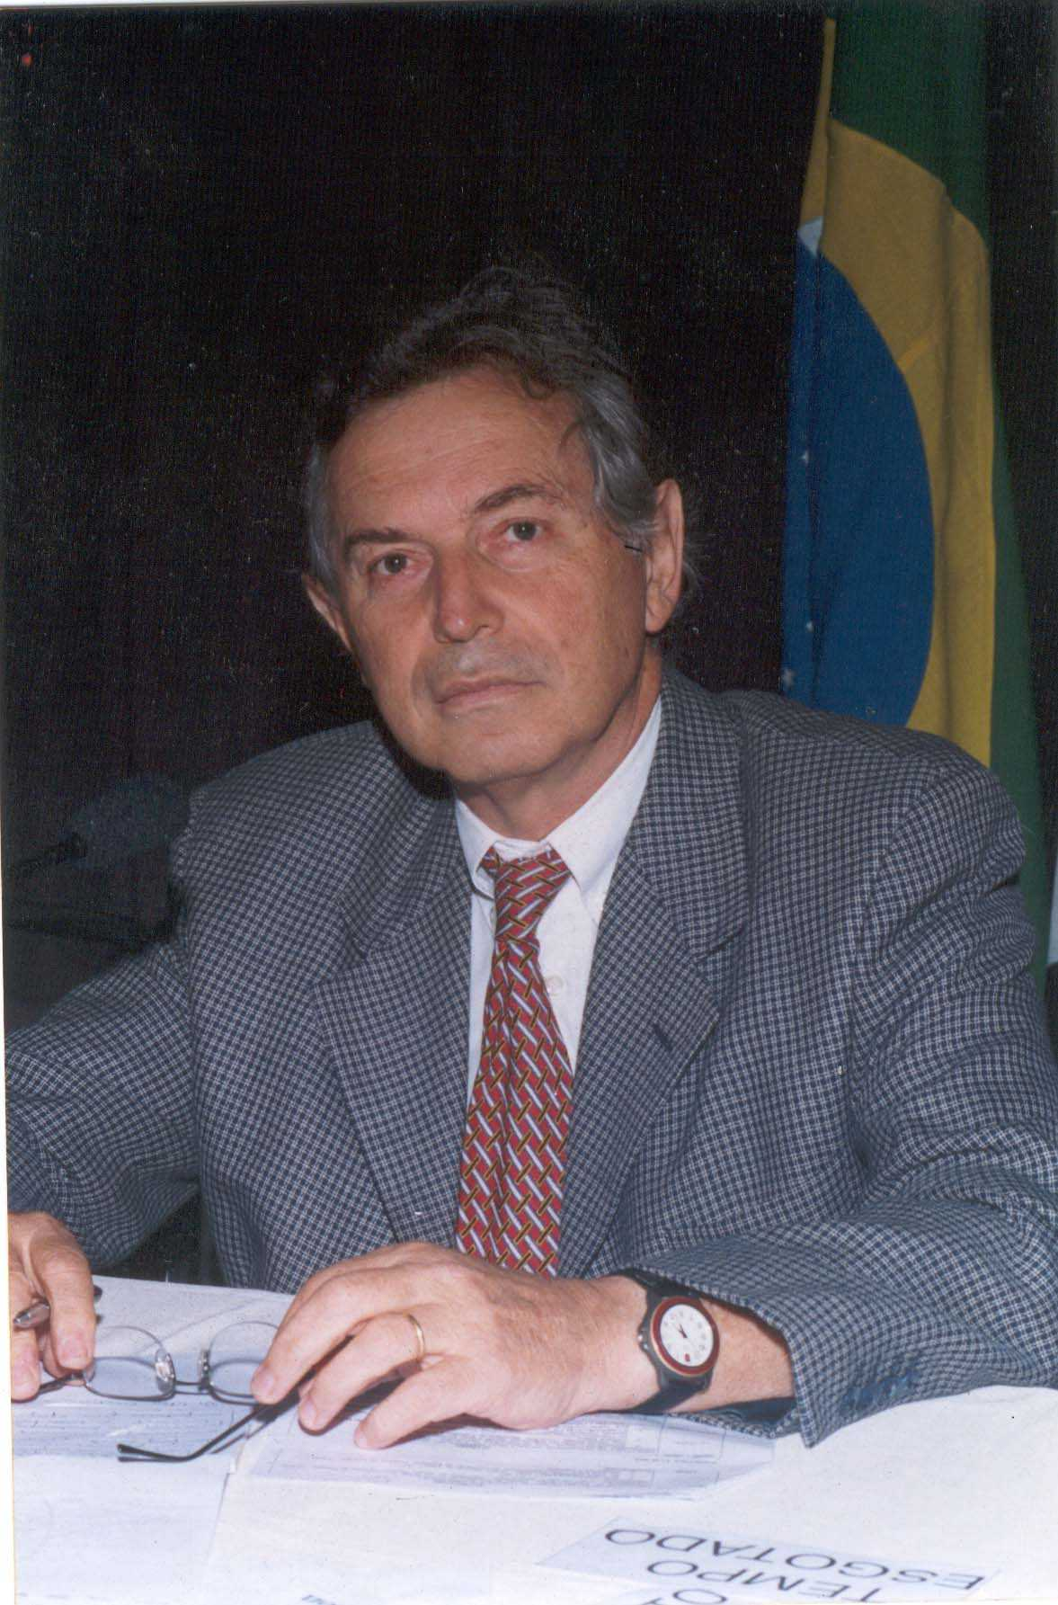
Leonídio F. Ribeiro Filho

Fax 55 ( 11 ) 3228-9528

Correio eletrônico
diretor.tecnico@abraphiset.com.br

